Caitlyn Jones
Prof. Yangyang Wang
MATH 40A: Intro to Applied Math
12 November 2024
Homework 4

  - α: growth rate of rabbits, unit = time⁻¹
β: constant that measures the number of rabbit-fox interactions that lead to rabbit deaths, unit = population⁻¹ * time⁻¹
γ = death rate of foxes, unit = time⁻¹
δ = constant that measures how beneficial it is for the fox’s population after eating rabbits, unit = population⁻¹ * time⁻¹
  - To modify to code from lab 4 and graph the results of the three initial populations, I first created variables for each of the four parameters.
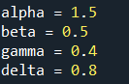

Then, I modified the function deriv(x,t) to properly implement the equations for $\frac{dR}{dt}$ and $\frac{dF}{dt}$.
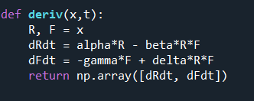

From here, I was able to plot the rabbit and fox populations for each of the three cases.
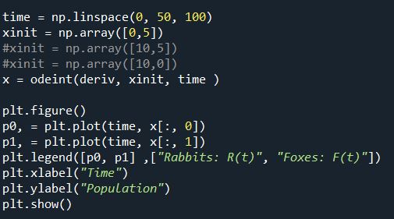

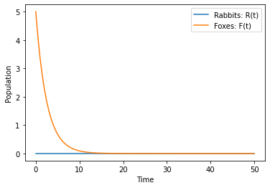
Starting with 5 foxes and 0 rabbits we get the following:

As we can see, the fox population will decrease to zero over time since there are no rabbits. Because the rabbits are the foxes’ prey, they will die out due to starvation.

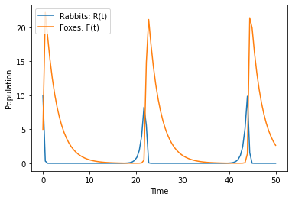
Next, we have the graph of 5 foxes and 10 rabbits below:

In this graph, we can see the oscillating behavior and the real-world cycle of predator and prey. As the rabbit population increases, the foxes are able to prey on them, increasing their own population. However, as the fox population increases, the rabbit population decreases, as more foxes are needing to hunt and prey on the rabbits. So, the rabbit population decreases, resulting in a decrease of the fox population. This is a continuous process, which replicates the predator-prey relationship in real life.
Lastly, we have the graph for 0 foxes and 10 rabbits below:
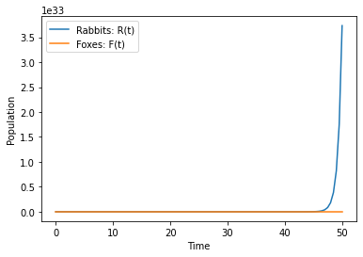
In this graph, we can see the rabbit population growing without any decreasing moments because there are no foxes for the rabbits to be hunted and killed by.

  - The susceptible group are the individuals who have not yet gotten the disease but are at risk of infection. The infected group are the people who have the disease. The removed group are the people who have been either killed by the disease or who have recovered and are now immune.
  - If there was single person in Boston who had bird flu, we can assume that S(t), susceptible people, would be N-1, given that N = Boston population. I(t) would be 1, and R(t) would be 0, since no one has yet recovered or died from this disease.
S(t) = N-1
I(t) = 1
R(t) = 0
  - The paper states that a flu epidemic can progress through a population assuming that any infected person is equally likely to come in contact with anyone in the susceptible group, regardless of social or geographic limitations. Also, the paper states that once a person is immune from the disease and calculated in the “removed” group, they are no longer for the transmission of the disease; they are assuming that after one time of getting this disease, a person gains permanent immunity.
  - The figure shows the deaths from a plague the spread throughout the island of Bombay. In the figure, we can see that the deaths are calculated over 30 weeks from December 17, 1905, to July 21, 1906. However, the graph is assuming that a plague in human beings reflects a plague in rats,
  - The population density threshold depends on the variable l and k, as the population density threshold is $N_{0}=\frac{l}{k}$. From here, as the paper states, “no epidemic can occur unless the population density exceeds this value”.

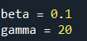
  - First, I implemented my SIR model using the given beta and gamma values.

Then, I graphed the function using the initial values of S = 90, I = 10, and R = 0.

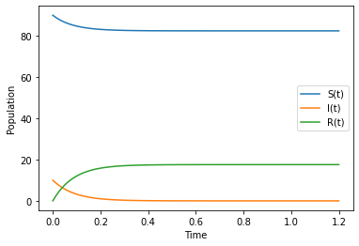
Below are the calculations for R₀:
$$R_{0}=\frac{β}{γ}$$
$$R_{0}=\frac{0.1}{20}$$
$$R_{0}=.005$$
Lastly, the total number of people who became sick is approximately 17.5686 or 18 people.
  - In order to estimate how many people became sick in the original and high-risk populations, I first modified my code from part (a) to add new parameters and new derived formulas.
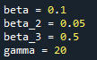

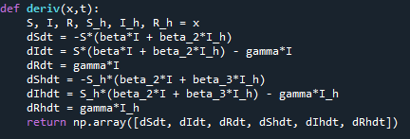

Then I solved the equations for the updated initial values.
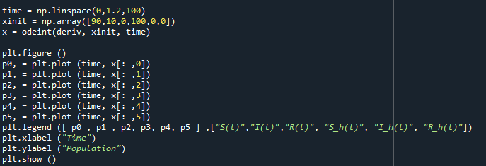
Here is the new graph with both the original and high-risk populations.
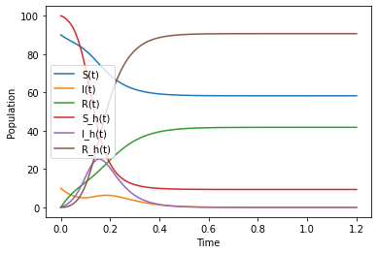
The number of people that became sick in the original population was 41.7776, or 42 people. In the high-risk population, there were 90.661, or 91 people.
  - One real world example we could use this model for would be a flu outbreak between the general population and a nursing home. The original group would be the rest of the population while the high-risk group would be the highly susceptible elders. In terms of public policy decisions, we can give out vaccines to the high-risk individuals first, then their caretakers, and then the rest of the population. Also, like during Covid, we can restrict human interactions so that the disease spreads at a lower rate.

